**PROOF**

**OF**

**RELATIONSHIP**

**-**

**HALDI PHOTOS**

In this document, we are attaching our photographs taken at our Haldi Event to support our relationship. We are also providing date and event of the place.

**HALDI CEREMONY**

**Date**: 10-02-2022 | **Place**: Pranith (Warangal)

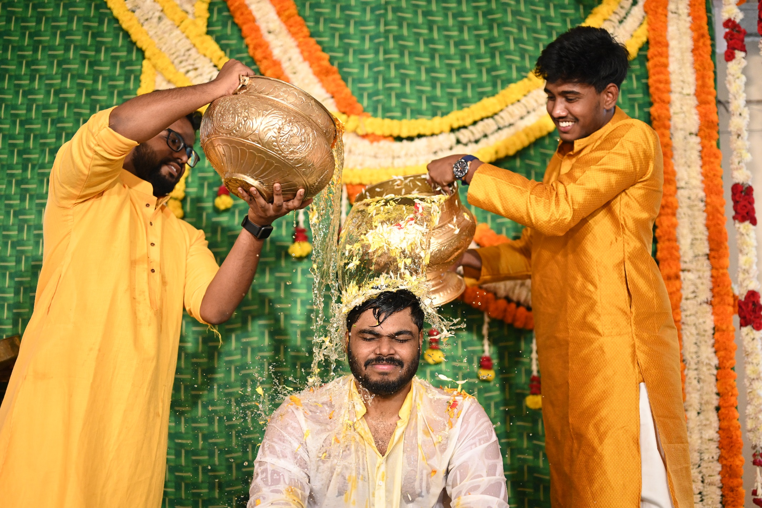

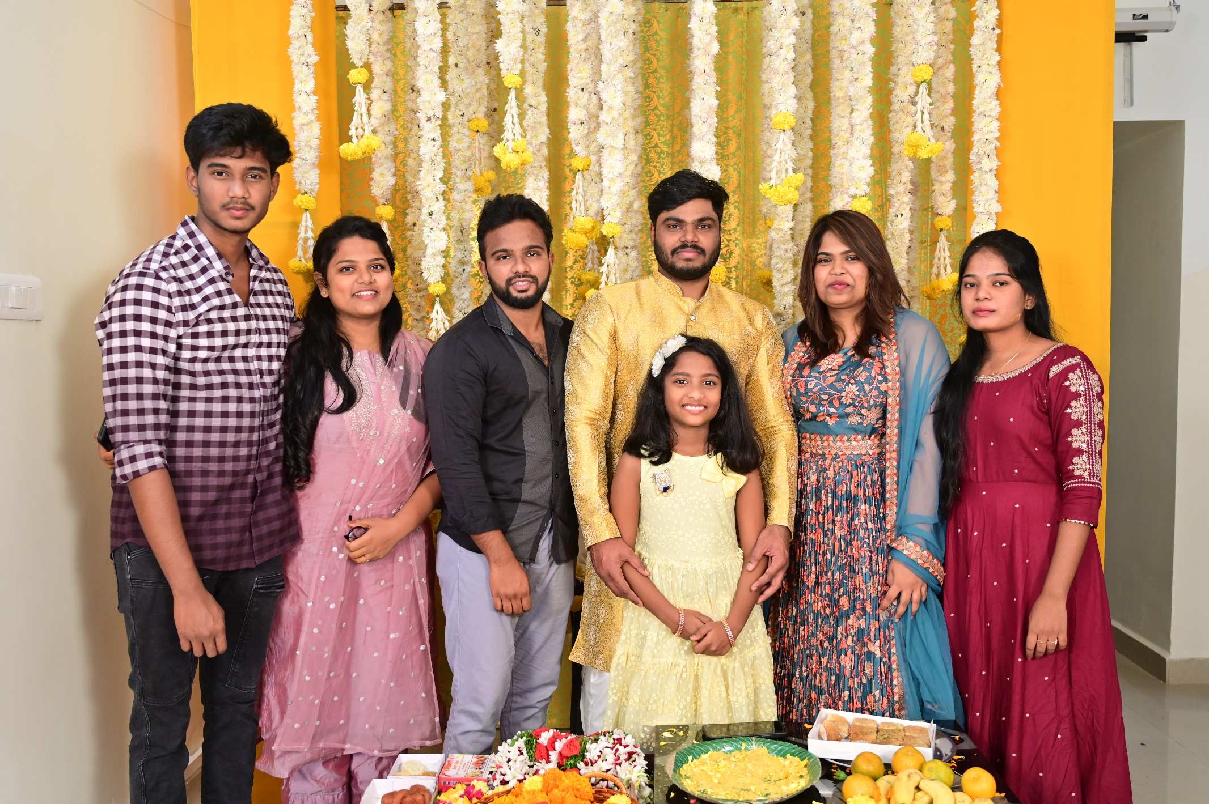

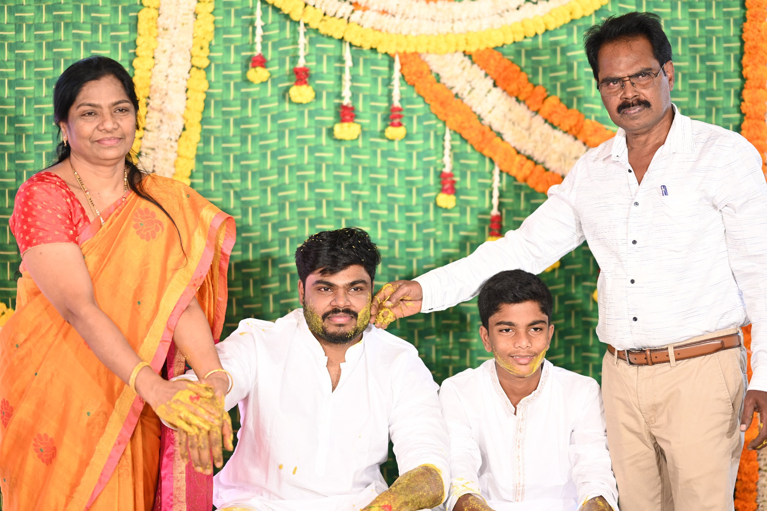

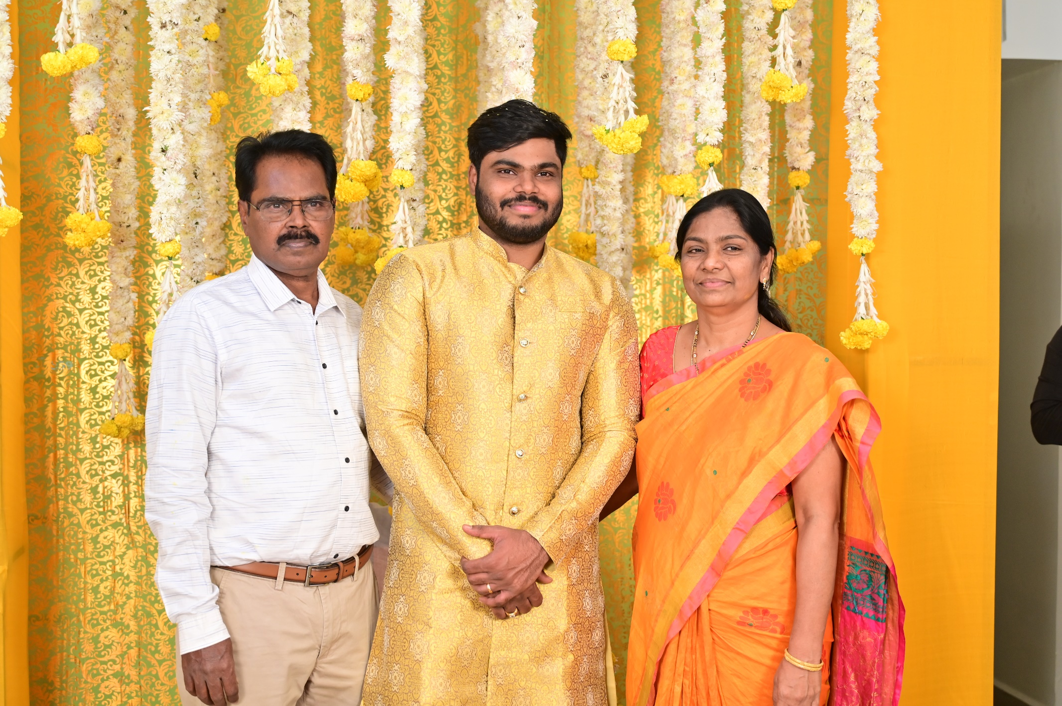

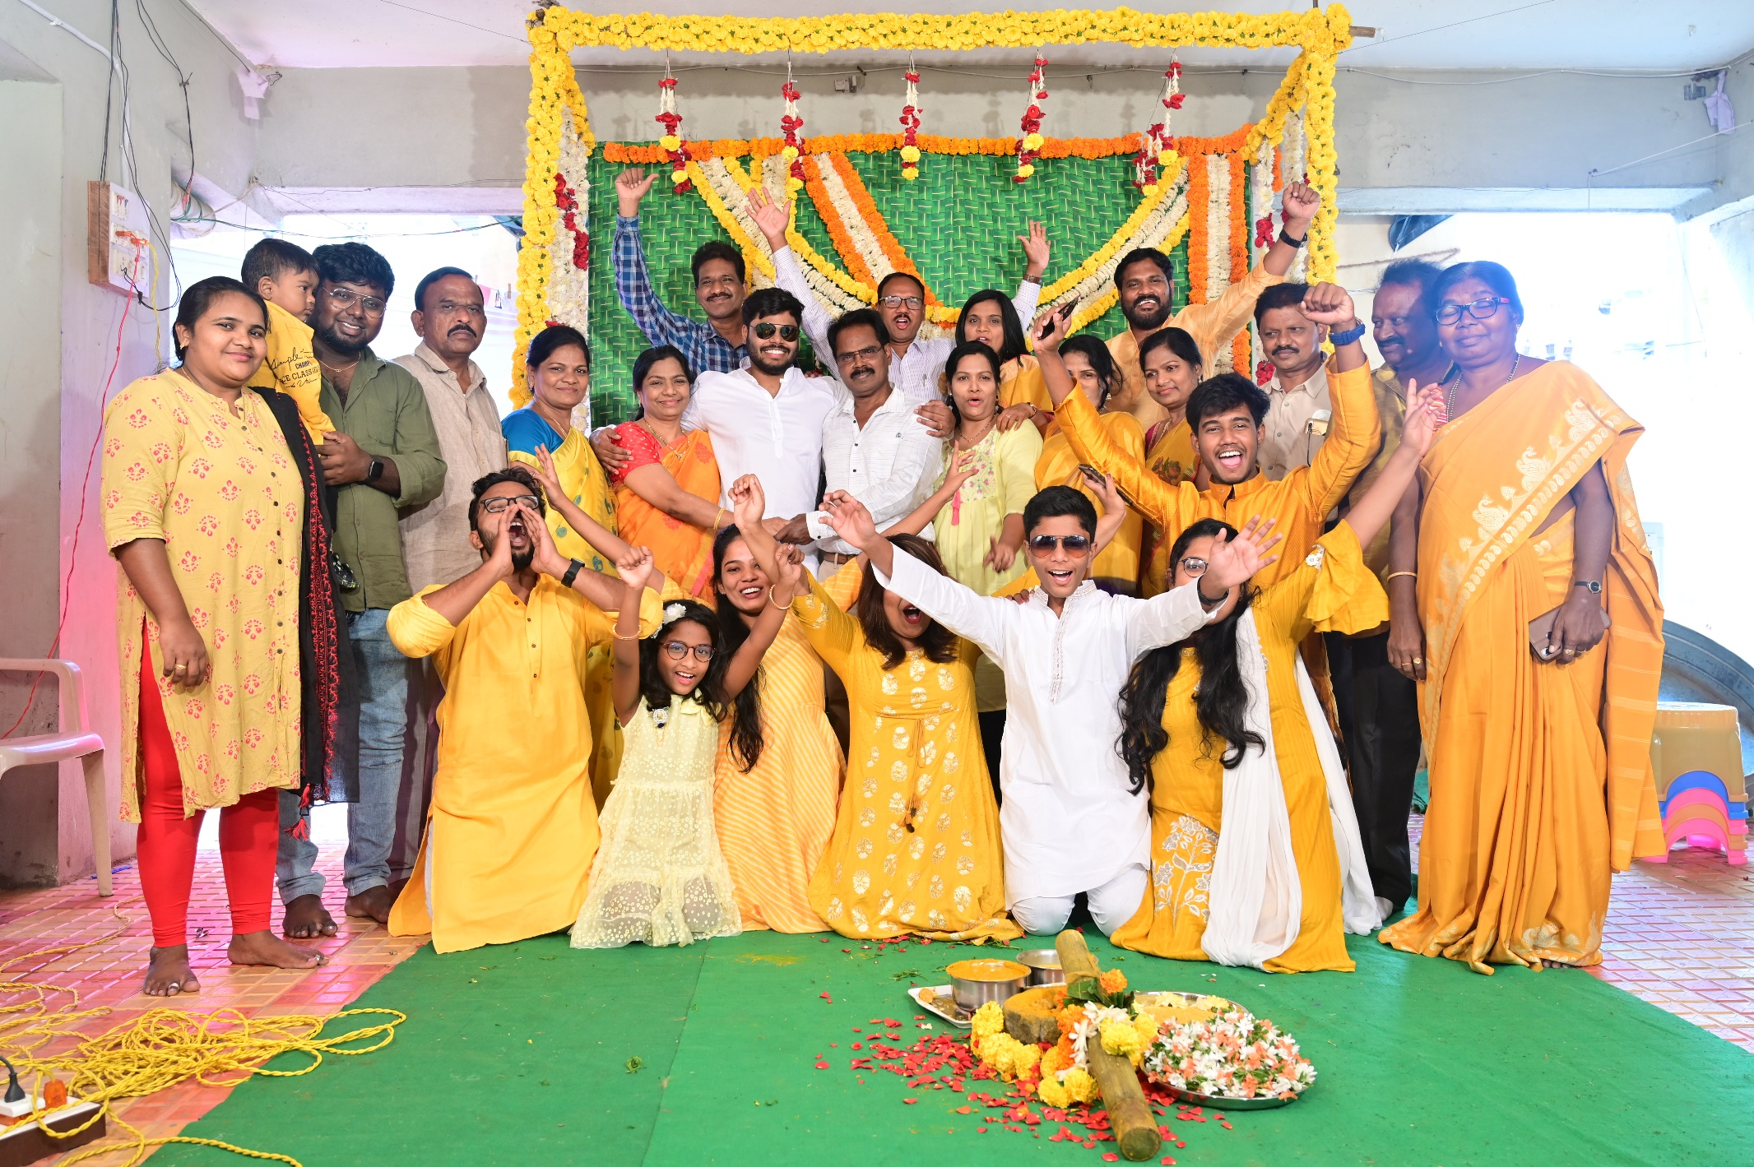

**Date**: 10-02-2022 | **Place**: Shirley Swaroopa (Hyderabad)

